Problem 1
Read in a number and print it out.

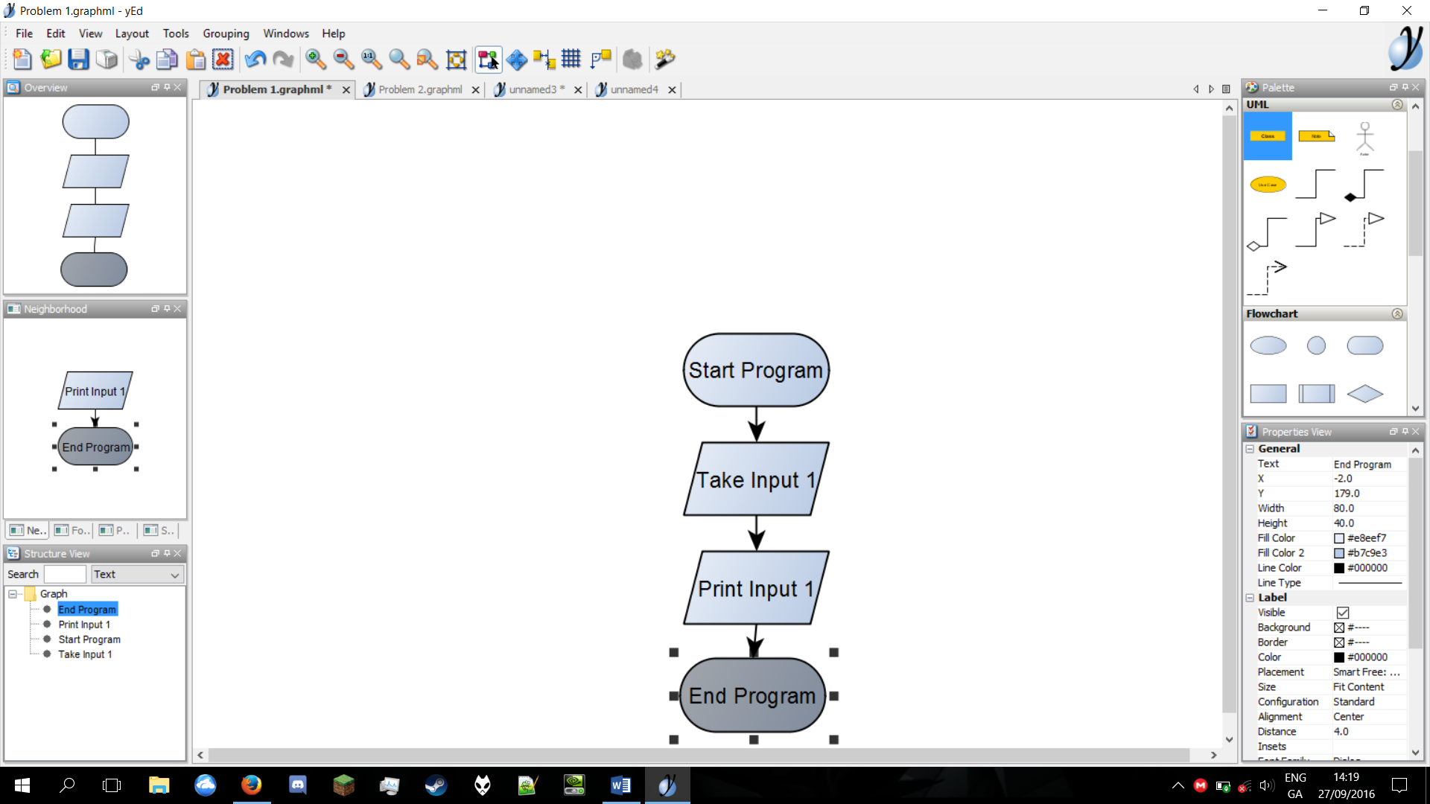

Problem 2
Read in a number and print out double the number.
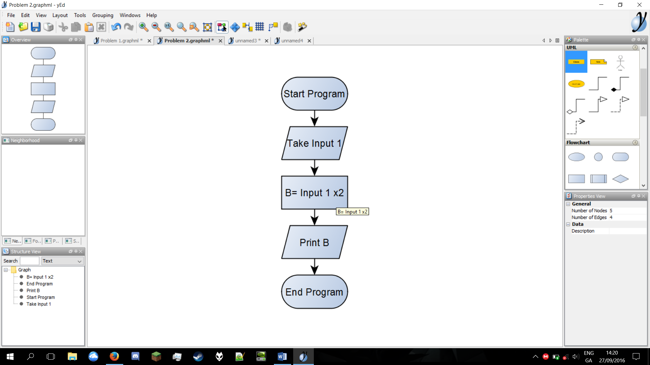

Problem 3
Read in a number, check if it is odd or even.

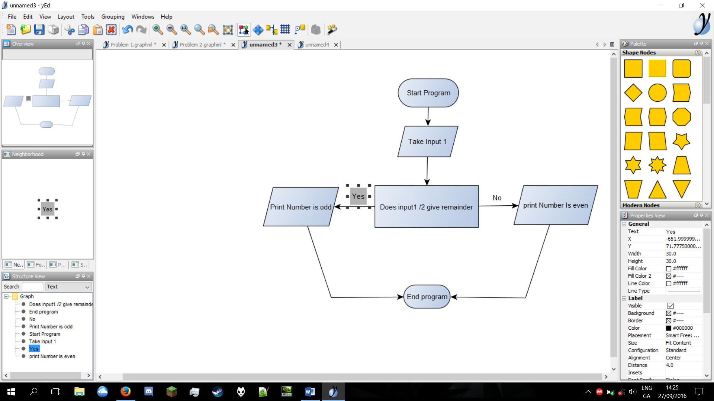

Problem 4
Read in two numbers, call them A and B. If A is bigger than B, print out A, otherwise print out B

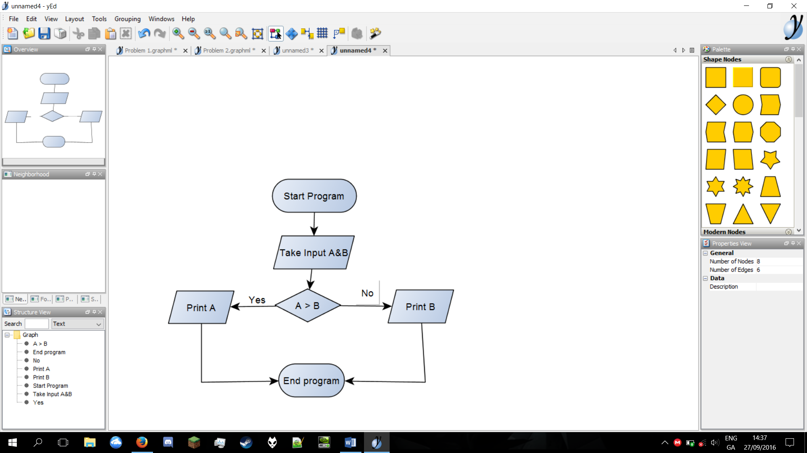

Problem 5

Read in two numbers, call them A and B. Sum A and B, print out the result.

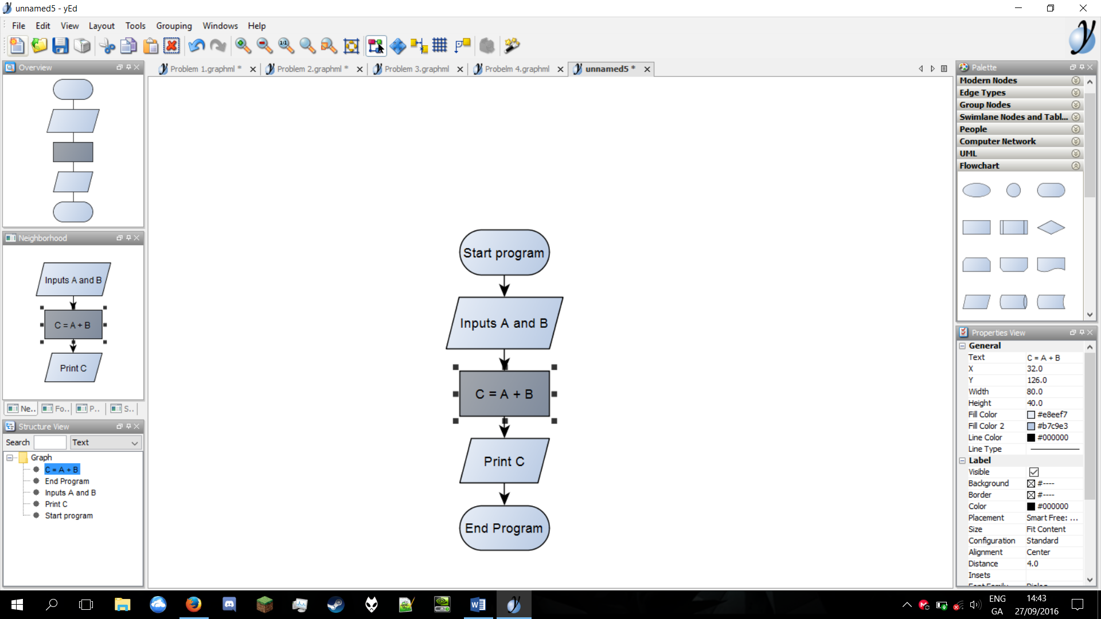

Problem 6

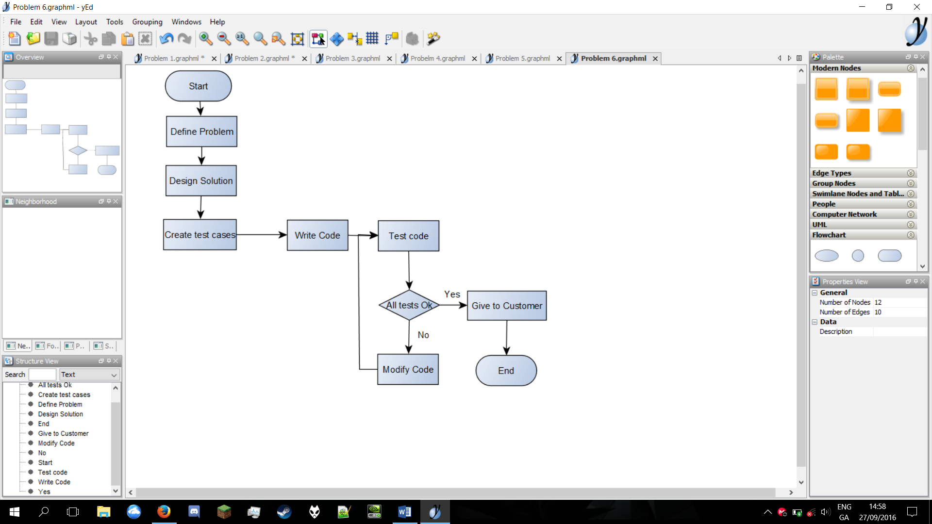

Problem 7
Read in three numbers, call them A, B and C. If A is bigger than B, then if A is bigger than C, print out A, otherwise print out C. If B is bigger than A, then if B is bigger than C, print out B, otherwise print out C.

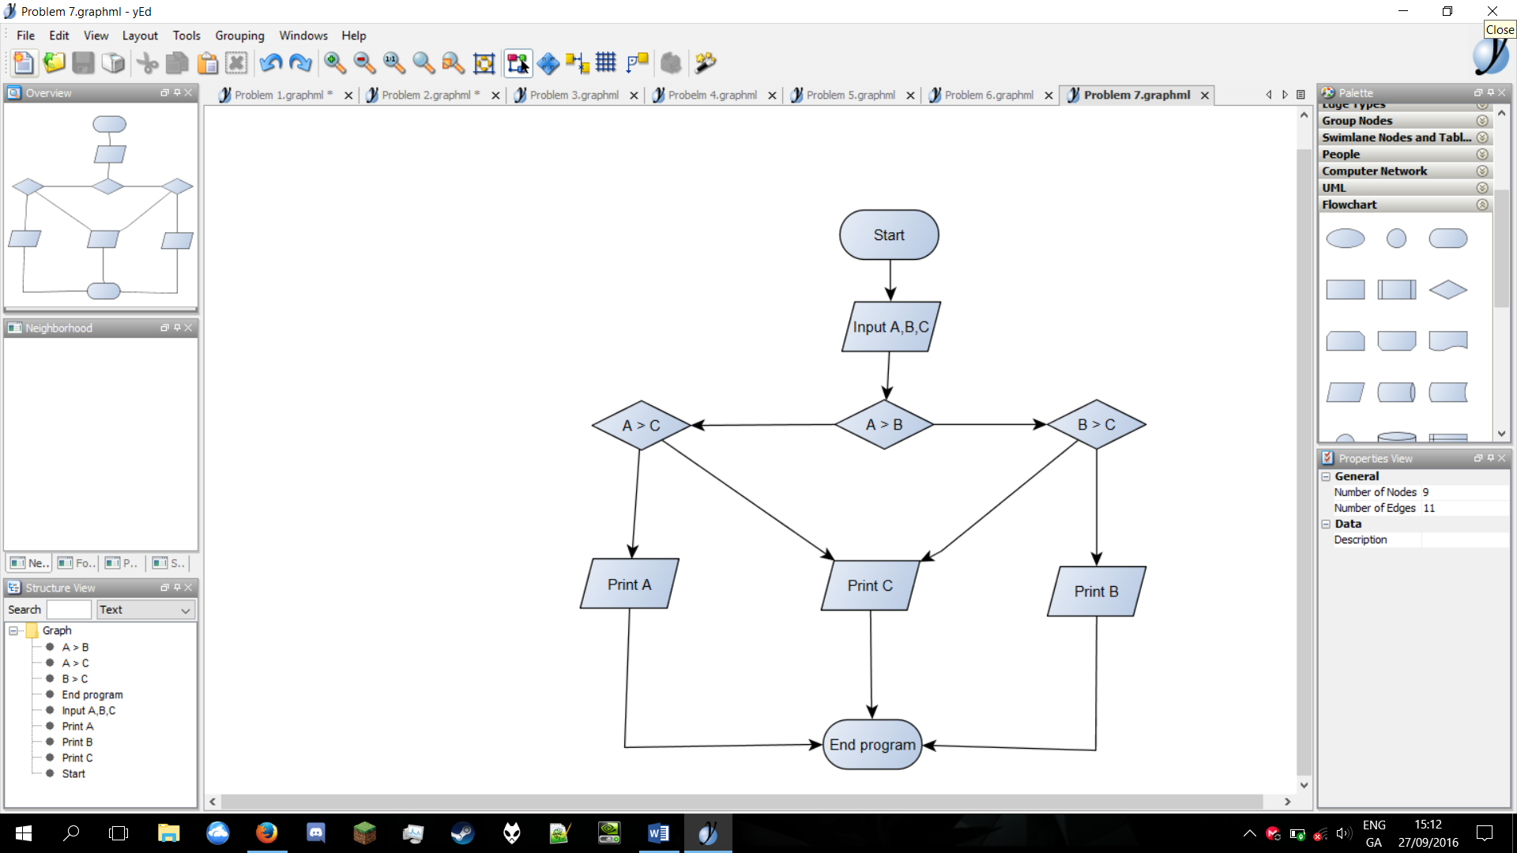

Night Club Problem
Construct a Flowchart to describe the logic to manage the front door of a night club. If the
person is 18 over allow them enter the nightclub, if they are not send them home!!

